Hosting different types of hosting For .net9anced way

1. Kestrel Hosting (Default Web Server)

What is it?
- Kestrel is the built-in cross-platform web server in ASP.NET Core.

How it works:
- Your .NET 9 Web API runs directly using Kestrel.
- It listens to HTTP requests.

Example:
dotnet run

Use Case:
- Development
- Microservices
- Container-based apps (Docker)

Key Point:
Kestrel is fast but not recommended alone for production on the internet

2. Reverse Proxy Hosting

What is it?
- Kestrel runs behind another web server like:
  - IIS
  - Nginx
  - Apache HTTP Server

How it works:
Client → IIS/Nginx → Kestrel → ASP.NET Core App

Benefits:
- Security
- Load balancing
- SSL handling
- Better production setup

Real-world Example:
Most enterprise apps use this setup

3. IIS Hosting (Windows Only)

What is it?
- Hosting ASP.NET Core app inside Internet Information Services

Two Modes:
- In-Process Hosting
  - Runs inside IIS worker process
  - Fastest performance
- Out-of-Process Hosting
  - IIS → Kestrel → App

Use Case:
- Enterprise Windows servers

4. Linux Hosting

What is it?
- Hosting on Linux servers using:
  - Nginx
  - Apache HTTP Server

How it works:
Client → Nginx → Kestrel → .NET App

Benefits:
- Cost-effective
- High performance
- Widely used in cloud

5. Cloud Hosting

Platforms:
- Microsoft Azure
- Amazon Web Services
- Google Cloud Platform

Services:
- App Services
- Virtual Machines
- Kubernetes

Use Case:
- Scalable production apps

6. Container Hosting (Docker)

What is it?
- Package app + dependencies into container using Docker

Example:
docker build -t myapp .
docker run -p 5000:80 myapp

Benefits:
- Portable
- Consistent environments
- Works with Kubernetes

7. Self-Hosting

What is it?
- App runs independently using Kestrel (no IIS/Nginx)

Example:
var builder = WebApplication.CreateBuilder(args);
var app = builder.Build();

app.Run();

Use Case:
- Lightweight apps
- Internal tools

8. Windows Service Hosting

What is it?
- Run your .NET app as a Windows Service

Use Case:
- Background jobs
- APIs running continuously

9. Linux Daemon (Systemd)

What is it?
- Run .NET app as a systemd service in Linux

Use Case:
- Production Linux servers

Quick Comparison Table
Hosting Type | Platform | Best For
Kestrel | Cross-platform | Dev, microservices
IIS | Windows | Enterprise apps
Nginx/Apache | Linux | Production hosting
Cloud | Any | Scalable apps
Docker | Any | DevOps, microservices
Windows Service | Windows | Background apps
Linux Daemon | Linux | Production APIs

Real-World Recommendation
For .NET 9 Web API (Production):
Linux Server + Nginx + Kestrel
OR
Azure App Service
For Learning / Practice:
Kestrel (dotnet run)

Interview Tip
If asked:
“Which hosting is best?”
Answer:
"Kestrel with a reverse proxy like Nginx or IIS is the recommended production setup in ASP.NET Core."

Deploy .NET 9 App on IIS (Step-by-Step)
We’ll deploy using Internet Information Services

Step 0: Prerequisites
Make sure your system has:
- Windows OS
- .NET 9 SDK installed
- IIS installed
- ASP.NET Core Hosting Bundle installed

Step 1: Install IIS

Enable IIS from Windows Features
- Press Win + R → type:
optionalfeatures
- Enable:
- Internet Information Services
- Web Management Tools
- World Wide Web Services
- Click OK → Restart PC

Step 2: Verify IIS Installation
- Open browser
- Go to:
http://localhost
You should see:
"IIS Default Page"

Step 3: Install .NET Hosting Bundle

Download:
- ASP.NET Core Hosting Bundle (for .NET 9)
This installs:
- .NET Runtime
- IIS Integration Module
Important:
After installing → Restart IIS
Iisreset

Note:- when running iisreset one window pop up coming and going . so who to check that

http://localhost (check this)
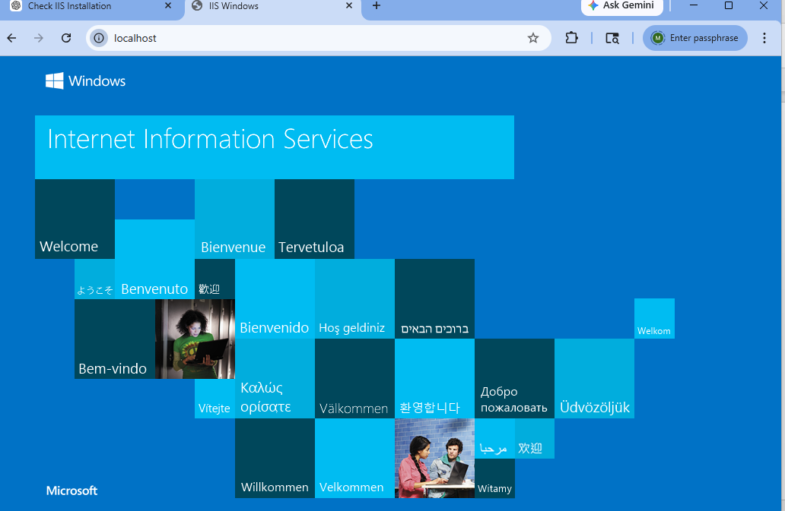

🏗️ Step 4: Publish Your .NET 9 Project
Open terminal in your project folder:
dotnet publish -c Release -o C:\Publish\MyApp
Output folder will contain:
- .dll
- web.config
- dependencies

Step 5: Create Folder in IIS Root
Create a folder:
C:\inetpub\wwwroot\MyApp
Copy all published files into this folder

Step 6: Give Folder Permissions
- Right-click folder → Properties
- Go to Security
- Add:
IIS_IUSRS
Give:
- Read
- Execute

Step 7: Create New Website in IIS
- Open IIS Manager
- Right-click Sites → Add Website

Fill details:
- Site Name: MyApp
- Physical Path:
- C:\inetpub\wwwroot\MyApp
- Port: 5000 (or 80)
Click OK

Step 8: Start Website
- Select your site
- Click Start

Step 9: Access Your App
Open browser:
http://localhost:5000
Your app should run

Step 10: Understand web.config (Important)
IIS uses this file to run your app:
<aspNetCore processPath="dotnet" arguments="MyApp.dll" />
This means:
IIS → ASP.NET Core Module → Kestrel → Your App

Common Errors + Fixes (VERY IMPORTANT)

Error 1: HTTP Error 500.30

Cause:
App failed to start

Fix:
- Check logs:
stdoutLogEnabled="true"

Error 2: 502.5 Process Failure

Cause:
- Missing runtime
- Hosting bundle not installed

Fix:
Install Hosting Bundle again

Error 3: Port Already in Use

Fix:
Change port in IIS bindings

Error 4: Permission Denied

Fix:
Give permission to:
IIS_IUSRS

Real-World Deployment Architecture
Client → IIS → ASP.NET Core Module → Kestrel → App

Next Level (Production Tips)

Use HTTPS
- Configure SSL certificate in IIS

Use App Pool Settings
- .NET CLR Version → No Managed Code

Enable Logging
- Use Serilog / log files

Auto Restart
- Configure Recycling in App Pool

Interview Question (VERY IMPORTANT)
What is IIS In-Process Hosting?
App runs inside IIS worker process
Faster than Out-of-Process

Hands-On Practice Task
Try this:
- Create Web API
- Publish it
- Deploy on IIS
- Hit API:
http://localhost:5000/api/values

If you want NEXT LEVEL++
I can give you:
IIS Deployment with SQL Server + Connection String
CI/CD Pipeline using Azure DevOps

Architecture Overview
We’ll use:
- Internet Information Services → Hosts your app
- Microsoft SQL Server → Stores data
- ASP.NET Core (.NET 9) → Your API / MVC app
Client → IIS → Kestrel → ASP.NET Core App → SQL Server

Step 0: Prerequisites
Make sure you have:
- IIS installed
- .NET 9 Hosting Bundle installed
- SQL Server installed (Local or Remote)
- SSMS (SQL Server Management Studio)

Step 1: Create Database in SQL Server
Open SSMS:
CREATE DATABASE MyAppDb;
GO

Step 2: Create Table
USE MyAppDb;

CREATE TABLE Employees (
Id INT PRIMARY KEY IDENTITY,
Name NVARCHAR(100),
Email NVARCHAR(100)
);

Step 3: Create SQL Login (IMPORTANT for IIS)
CREATE LOGIN myuser WITH PASSWORD = 'StrongPassword@123';
USE MyAppDb;

CREATE USER myuser FOR LOGIN myuser;
ALTER ROLE db_owner ADD MEMBER myuser;
This allows IIS app to access DB securely

Step 4: Add Connection String in appsettings.json
{
"ConnectionStrings": {
"DefaultConnection": "Server=localhost;Database=MyAppDb;User Id=myuser;Password=StrongPassword@123;TrustServerCertificate=True;"
}
}

Alternative (Windows Authentication)
"DefaultConnection": "Server=localhost;Database=MyAppDb;Trusted_Connection=True;TrustServerCertificate=True;"
Use this when IIS runs under Windows identity

Step 5: Configure DbContext (.NET 9)
builder.Services.AddDbContext<AppDbContext>(options =>
options.UseSqlServer(builder.Configuration.GetConnectionString("DefaultConnection")));

Step 6: Publish Your App
dotnet publish -c Release -o C:\Publish\MyApp

Step 7: Copy to IIS Folder
C:\inetpub\wwwroot\MyApp
Paste published files

Step 8: Give Folder Permissions
Give access to:
IIS_IUSRS
Read
Execute

Step 9: Create Site in IIS
Open IIS Manager:
- Site Name: MyApp
- Path: C:\inetpub\wwwroot\MyApp
- Port: 5000

Step 10: Configure Application Pool
VERY IMPORTANT
- .NET CLR Version → No Managed Code
- Managed Pipeline → Integrated

Step 11: Database Access from IIS (CRITICAL STEP)

If using SQL Authentication
Already works (username/password in connection string)

If using Windows Authentication

Step 1: Find App Pool Identity
Example:
IIS APPPOOL\MyApp

Step 2: Give SQL Access
CREATE LOGIN [IIS APPPOOL\MyApp] FROM WINDOWS;
USE MyAppDb;
CREATE USER [IIS APPPOOL\MyApp] FOR LOGIN [IIS APPPOOL\MyApp];
ALTER ROLE db_datareader ADD MEMBER [IIS APPPOOL\MyApp];
ALTER ROLE db_datawriter ADD MEMBER [IIS APPPOOL\MyApp];

Step 12: Run Migration (If using EF Core)
dotnet ef database update
Or run automatically in startup:
using (var scope = app.Services.CreateScope())
{
var db = scope.ServiceProvider.GetRequiredService<AppDbContext>();
db.Database.Migrate();
}

Step 13: Test Application
Open:
http://localhost:5000
Try API:
/api/employees

Common Errors + Fixes (VERY IMPORTANT)

Login Failed for User

Cause:
Wrong credentials or no permission

Fix:
- Check SQL login
- Check connection string

Cannot Open Database

Fix:
USE MyAppDb;
ALTER ROLE db_owner ADD MEMBER myuser;

Network-related Error

Fix:
- Enable TCP/IP in SQL Server Configuration Manager
- Allow port 1433 in firewall

500 Error in IIS

Fix:
Enable logs in web.config:
stdoutLogEnabled="true"
stdoutLogFile=".\logs\stdout"

Best Practices (Production Level)

1. Store Connection String Securely
Don’t hardcode password
Use:
- Environment variables
- Azure Key Vault

2. Use Least Privilege
Instead of db_owner, use:
- db_datareader
- db_datawriter

3. Enable Connection Pooling
(Default enabled in SQL Server)

4. Use HTTPS
Configure SSL in IIS

Real-World Scenario
Example:
- E-commerce app deployed on IIS
- SQL Server on another machine
- Connection string uses:
Server=192.168.1.10;Database=ProdDb;User Id=appuser;

Interview Question (VERY IMPORTANT)
How does IIS connect to SQL Server?
Through connection string
Either:
- SQL Authentication
- Windows Authentication

Hands-On Practice
Build:
- Employee CRUD API
- Use EF Core
- Deploy on IIS
- Connect to SQL Server
- Test using Postman

NEXT LEVEL++
If you want deeper 🚀
Next we will do below topics
Connection String Encryption (VERY IMPORTANT)
Multi-Environment setup (Dev / QA / Prod)
Azure SQL + IIS Deployment
CI/CD pipeline with DB migration
Real-world debugging case study (company-level issues)

8888888888888888888888888888888888888888888
How to install asp.net core window hosting bundle installer

Download:
- ASP.NET Core Hosting Bundle (for .NET 9)
Here’s a clear step-by-step guide to download and install the ASP.NET Core Hosting Bundle (.NET 9) on your system (for IIS hosting)

Step-by-Step: Install ASP.NET Core Hosting Bundle (.NET 9)

Step 1: Go to Official Download Page
Open this in your browser:
Visit: ASP.NET Core download page
(official Microsoft site)

Step 2: Select .NET 9
- Scroll down to “.NET 9 (Latest)”
- Look for section:
Run apps – Runtime

Step 3: Download Hosting Bundle
Find:
ASP.NET Core Runtime → Hosting Bundle
Click:
Download Hosting Bundle (Windows)

Step 4: Run Installer
After download:
- Go to Downloads folder
- Double-click the .exe file

Step 5: Install
Follow installation wizard:
- Click Next
- Accept license terms
- Click Install
Wait for installation to complete

Step 6: Restart IIS (VERY IMPORTANT)
After installation:
Open Command Prompt (Run as Admin) and run:
iisreset
This ensures IIS picks up the new runtime

Step 7: Verify Installation
Run:
dotnet --info
You should see:
- .NET 9 Runtime
- ASP.NET Core Runtime installed

Where This Gets Installed?
It installs automatically into:
C:\Program Files\dotnet\
You don’t need to choose location manually 👍

What Gets Installed?
The Hosting Bundle includes:
- .NET Runtime
- ASP.NET Core Runtime
- IIS Integration Module
This allows IIS to run your Web API / MVC app

Important Tips

Install on:
- Your IIS Server
- OR your local machine (if using IIS locally)

If IIS already open:
Restart it after install (iisreset)

If app not running:
Check:
- Hosting bundle installed?
- Correct .NET version?
- App Pool settings?

Quick Summary
Step | Action
1 | Go to .NET 9 download page
2 | Select Hosting Bundle
3 | Download
4 | Install
5 | Run iisreset
6 | Verify using dotnet --info

If you want next 🚀
I can give you:
Full IIS deployment (step-by-step with screenshots-style explanation)
Publish + Deploy .NET 9 Web API
Fix common IIS errors (500.30, 502.5, etc.)
Just say "next level IIS setup"

